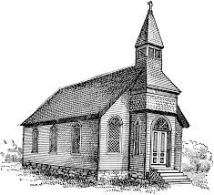
Why Be Catholic?
Discovering the Church Jesus Founded
The One True Church
- What are the four “marks of the Catholic Church?
_________________ ________________
_________________ ________________

- Who was the “rock” to whom Jesus gave the “keys to the kingdom,” appointing him to lead the church?
______________________________________
Read Matthew 16:19

- Which of the three Persons of the Blessed Trinity is considered the “guardian and protector “of the Church? _______________________________

Discuss
If someone asked you, “Why are you Catholic?” how would you answer?
What does the term “Cradle Catholic” mean to you?

Do you know someone who converted into the church? Why do you think he or she converted?

What are some other reasons people might want to become Catholic?

Apostolic and Catholic
- The word “catholic” means _______________

- The teaching authority of the Church is called the ____________.

- The word infallible means without
____________________________.
Discuss
- If you started a club or a company, what are some reasons it would be important to establish an organization, visible, and structured leadership?

- What are some roles you have in the Church that priests do not have?

- Why is it important that we recite the Nicene creed at Mass each week?

- Look up 1 Corinthians 12:12-18
What part are you in the
body of Christ and why?

The Church is Holy

- The Church has both a visible and _____________________ reality.

- The Church is often referred to as our __________________________, who is always there for us.

Discuss
- What are some ways the Church makes Jesus Christ and his saving work a visible reality in the world today?

- How would you respond to someone who questions the Church’s holiness?

“You are fellow citizens with the saints and members of the household of God, built upon the foundation of the apostles and prophets, Christ Jesus himself being the cornerstone…” ~ Ephesians 2:19-20

