Community Life
Lesson 4 Make up work
“All Are Welcome and Trust”

Have you ever been left out? How did it feel? ______________________________________________________________________________

Think of STOP when you see people being left out “Hands and Feet of Christ”
S = stands for Spirit
T = stands for think
O = stands for others
P = stands for pray

How will you use STOP in the future? ____________________________________________________________________________________________________________________________________________________________

What did you learn from reading Matthew 25:31-46? ____________________________________________________________________________________________________________________________________________________________

What is Faith?
______________________________________________________________________________

What does Hebrews11:1 say about faith? ______________________________________________________________________________
When have you been untrustworthy? What were the Consequences ___________________________________________________________________________________________________________________________________________________________
List 5 people you trust: __________________________________________________________
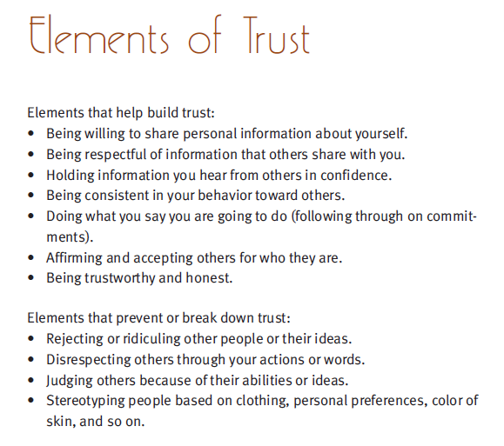
What is the importance of trustworthiness?

