Community Life
Lesson 3 Make up work “Music And Me”

“Tuning in”
- Landscape Paper in middle write your name
- Top left artist and song you would have brought to class
- Bottom right “Style of music they like”
- Top right “Favorite CD” (Other than one they brought today)
- Bottom left “Least favorite music”
- Above name “5 favorite artists”
- Below name “5 things they like about their music”

Listen to–Lose my soul by TobyMac –name a phrase that stuck out as you listened and why? ____________________________________________________________________________________________________________________________________________________________

Read below: What did you learn from this article? ____________________________________________________________________________________________________________________________________________________________
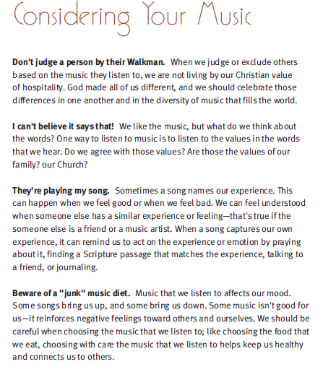

Read Psalm 91
What church hymn have you sung that is from this Scripture writing? ______________________________________________________________________________

